YInception

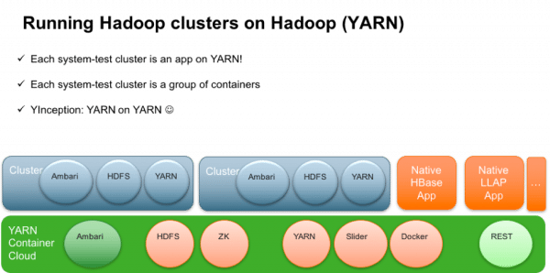

https://zh.hortonworks.com/blog/yinception-yarn-based-container-cloud-certify-hadoop-hadoop/

https://www.hindawi.com/journals/sp/2018/5418679/

https://zh.hortonworks.com/blog/apache-hadoop-3-1-giant-leap-big-data/

https://zh.hortonworks.com/blog/apache-hadoop-3-1-0-released-and-a-look-back/

<https://zh.hortonworks.com/blog/hadoop-3-adds-value-hadoop-2/>

Docker on YARN:

https://zh.hortonworks.com/blog/yinception-yarn-based-container-cloud-certify-hadoop-hadoop/

https://zh.hortonworks.com/blog/trying-containerized-applications-apache-hadoop-yarn-3-1/

<https://zh.hortonworks.com/blog/first-class-support-long-running-services-apache-hadoop-yarn/>

https://zh.hortonworks.com/blog/part-5-of-data-lake-3-0-yarn-and-containerization-supporting-docker-and-beyond/